


Health Equity Leadership Program

Empowering Leaders. Getting to Solutions.

Developed and led by
The Disparities Solutions Center at Massachusetts General Hospital

Winner of the
2014 American Hospital Association Equity of Care Award
and the AAMC Learning Health System Award

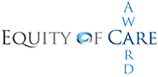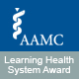

Jointly sponsored by
The National Committee for Quality Assurance
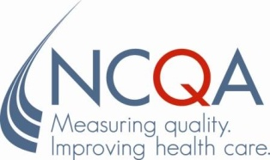

Supported by
Joint Commission Resources, Inc. (An Affiliate of The Joint Commission)



What we have learned from working with other health care organizations for over a decade is that there is a thirst for knowledge on how to operationalize and execute on strategies to address health equity, but also to be part of a community that can crowdsource ideas.

Aswita Tan-McGrory, MBA, MSPH
Director, The Disparities Solutions Center at Massachusetts General Hospital
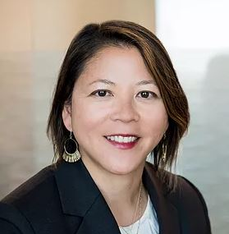

Pursuing High-Value Health Care: Improving Quality and Achieving Equity

The implementation of health reform and current efforts in payment reform herald a significant transformation of the United States' health care system. Across the country, health care organizations are expanding access to health care that aims to be high-quality and cost-effective. Pursuing high-value health care is the ultimate goal.

Guided by The Institute of Medicine (IOM) Report Crossing the Quality Chasm, our nation charts a path towards quality health care that aims to be safe, efficient, effective, timely, patient-centered, and equitable. Achieving equity requires that the quality of care we deliver—and that patients receive—does not vary based on patient characteristics such as race/ethnicity, gender, sexual orientation, and disability status. If we are to be successful in our pursuit of value, we must be prepared to deliver high-quality and high-value health care to an increasingly diverse population. Health equity is a high-value target and will allow health care organizations to gain a competitive edge in a changing market.

Preparing for Healthcare Transformation: The Health Equity Leadership Program

The Disparities Solutions Center (DSC) at Massachusetts General Hospital is dedicated to helping health care leaders address health equity in a time of healthcare transformation. The Health Equity Leadership Program will equip you with the knowledge, tools, and strategies you will need to achieve health equity and deliver high-value, quality care to all.

Since 2005, the DSC has worked to improve health care quality for every patient, regardless of race, ethnicity, culture, class, or language proficiency. Our work is focused on developing actionable strategies to improve quality and achieve equity that are designed for those on the front lines of health care. We provide tools to identify gaps, develop models to address them, and then work closely with health care leaders to deploy them in their unique care settings. From our home at the Massachusetts General Hospital and Harvard Medical School, we draw on our rich legacy of conducting cutting-edge research and translating it into practical, actionable strategies that are built to be integrated in real care settings. Our multidisciplinary group – with expertise in health policy, health equity, quality improvement, clinical care, patient experience, and organizational transformation – is committed to working closely with health care stakeholders to help achieve equity in this time of healthcare transformation.
Specifically, we:
- Create change by developing new research and translating the findings into policy and practice.
- Find solutions that help health care leaders, organizations, and key stakeholders ensure that every patient receives high-value, high-quality health care.
- Encourage leadership by expanding the community of health care professionals prepared to improve quality and achieve equity.
The Health Equity Leadership Program (HELP) is our year-long, hands-on executive education program focused exclusively on helping health care leaders achieve equity in quality. The program is designed to help you translate the latest understanding of health equity into realistic solutions you can adopt within your organization.
Through the HELP, we develop leaders prepared to meet the challenges of health care transformation by improving quality for populations who experience gaps in care. The program has three main goals:
- To equip health care leaders with a rich understanding of the causes of health equity, the vision to implement solutions, and the strategies to transform their organization to deliver high-value health care.
- To help leaders create strategic plans or projects to advance their work in health equity in a customized way, with practical benefits tailored to every organization.

- To create a professional learning and networking environment for leaders in health care to engage in peer-to-peer learning, crowdsourcing of ideas and strategies for reducing gaps in care, resource sharing, collaboration, and ongoing support in the form of a national HELP alumni network.
The DSC has the unique advantage of 19 years of experience developing and implementing the HELP, the only program of its kind in the nation.
To date, the HELP has trained 18 cohorts that include a total of 599 participants from 252 organizations (127 hospitals, 73 health plans, 22 community health organizations, and 30 others, including professional organizations, hospital trade organizations, schools of medicine, and federal and state government agencies) representing 36 states, Washington D.C., the Commonwealth of Puerto Rico, Canada, and Switzerland.
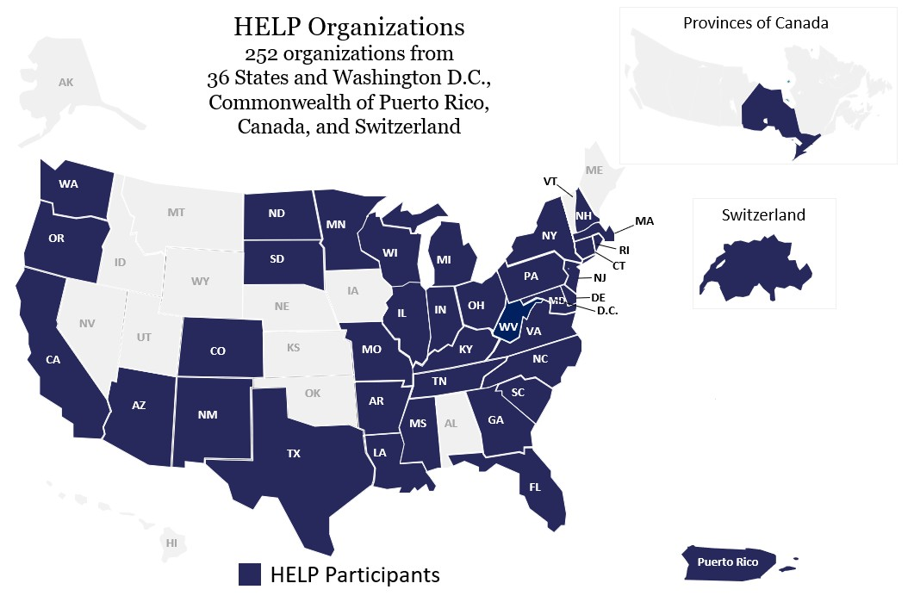
Leaders of health care organizations need to be prepared to improve quality and achieve equity in today’s health care environment, characterized by a focus on achieving value and addressing gaps in care. To help address this need, the Disparities Solutions Center at Massachusetts General Hospital launched the Health Equity Leadership Program in 2007. Feedback from participating organizations demonstrates that health care leaders seem to possess knowledge about what the gaps in care are and about what should be done to eliminate them. Data collection, performance measurement, and multifaceted interventions remain the tools of the trade. However, the barriers to success are a lack of leadership buy-in, organizational prioritization, energy, and execution, which can be addressed through organizational change management strategies.

“What HELP has done is to awaken a part of me. It brought me to an awareness level that has made me more well-rounded… This program has made me think about patients and families differently, it has helped me think about the community differently, making my work with the community much stronger... It has made me more sensitive and appreciative of differences. It has made me much stronger as a leader.”
- HELP Alum

x
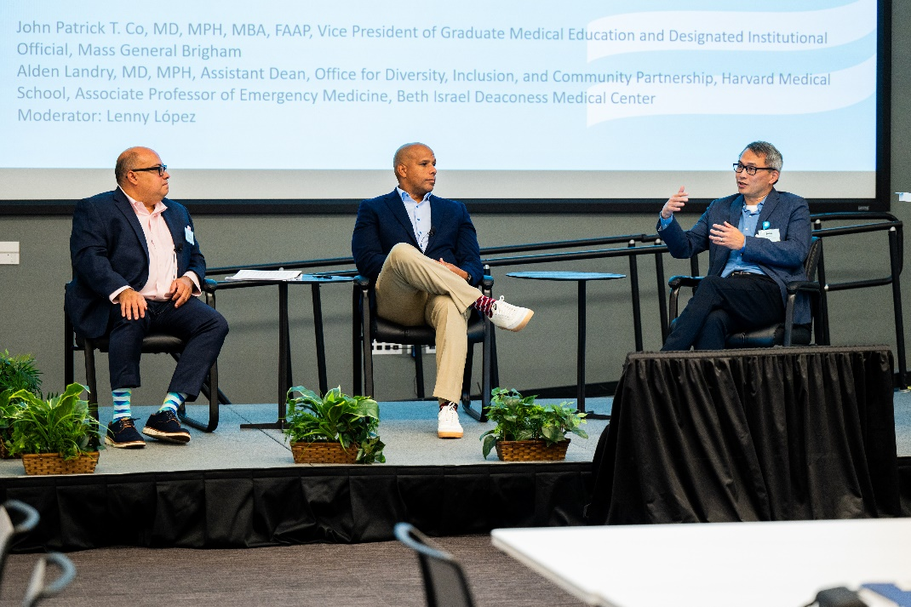

Who should apply?
The HELP is for leaders who recognize that gaps in care and in quality impact outcomes and the health care bottom line; it is for pioneers who seek solutions to improve quality, achieve equity, and deliver value within the context of health care reform and transformation while focusing on meeting the needs of diverse populations.

Participants in our program come from a variety of disciplines and backgrounds and a range of organizations, including hospitals, health plans, physician groups, community health centers, and other care settings. Their roles include, among others:
- Executive Leadership
- Medical Directors
- Chief Diversity Officers
- Vice Presidents of Quality
- Directors of Patient Care Services
- Directors of Multicultural Affairs or Community Benefits

Teams of at least two participants from a given organization are routine, yet we encourage larger teams if beneficial, and we can work with individuals as well. To maximize the benefits of the HELP, your organization should have a strong commitment to solving the problem, as well as resources available to create change. Our team can work with you to find and strengthen those resources within your organization.

What will I gain from the HELP?
Addressing health equity and improving the value of health care requires leadership, vision, teamwork, and an understanding of the problem and potential solutions. The HELP is designed to build your knowledge and skills in these key areas while connecting you with other leaders and organizations working toward the same goal.

As a HELP participant, you’ll gain tools you can apply immediately at your organization to improve health equity:
- A Strong Network and Community of Peer Leaders. Through the HELP, you’ll collaborate with other like-minded individuals dedicated to solving this problem. You’ll be able to leverage crowdsourcing, share strategies, and walk away with valuable lessons learned. HELP alumni report that their peer network helps them access resources and reaffirm their path forward long after they complete our program.
- Strategies for Organizational Change. Our program will help you articulate the ways in which equity is linked to the bigger picture of value and health care reform. You’ll leave better able to make the case for change and garner the support of key stakeholders within your organization. The majority of our alumni report that the program gave them a new vision of their role as a health care leader able to foster meaningful change.
- A Clear Path Forward. Through the HELP, you’ll identify techniques and strategies that can be immediately deployed to address health equity within your organization. By tackling real-world situations through HELP projects, you’ll leave with concrete steps and a plan of action.
- Critical Support. Through your project work and your HELP peer network, you will receive practical support and feedback that will help you to build and refine strategies long after your HELP year is over.

At the conclusion of this program, HELP participants will be able to:
- Understand the impact of history in addressing health equity
- Identify how building a diverse pipeline and organization can help achieve equity.
- Articulate the ways in which equity is linked to healthcare transformation, healthcare reform, value-based purchasing, accreditation, and quality measurement.
- Identify organizational change management strategies to achieve equity.
- Understand methods for social determinants of health data collection and performance measurement across the system.
- Identify how to deploy surveys to better understand your organization’s culture and strategies for improving the culture.
- Identify ways to message the issue of equity both internally and externally.
- Identify steps toward building bridges focused on community health and increasing partnerships with communities in research.
- Describe a concrete step that their organization will take towards improving quality and achieving equity.

Previous participants have gone on to achieve meaningful results, including:
- Developing and executing system-wide strategic plans to achieve health equity
- Establishing new leadership positions, increasing staffing, and forming equity councils that oversee improvement efforts.
- Successfully deploying tactics such as improved data collection systems and dashboards that monitor quality stratified by demographic data.
- Developing quality improvement strategies to achieve equity, such as in the areas focused on diabetes and preventing congestive heart failure readmissions.
- Improving training programs to educate the C-suite, health care providers, and staff
“The HELP is a critical capacity-building engagement that will have enduring value through the networking, resource sharing, and collective voice to advance health equity.”
–Academic Center and Health System Alum

How does the HELP work?
The HELP begins with an intensive, two-day training session, followed by structured, interactive, distance learning that will allow you to develop a strategic plan or advance an ongoing project focused on quality, equity, and inclusion.

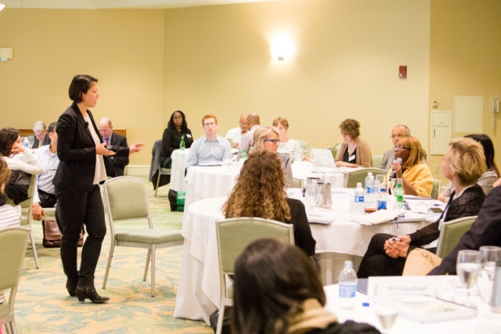
Kick-off Meeting
The two-day virtual HELP kick-off meeting provides you with a framework for understanding how to achieve equity and the solutions you will develop over the course of the year. Experts at the DSC, MGH, and other top health care organizations lead discussions on strategies to achieve equity and inclusion and how to foster the leadership skills to implement these strategies. Examples of the topics covered during the kick-off meeting include:
- Using the Kotter Model to Lead Change
- History of our country and the Long-Lasting Impact on Healthcare
- Overview of Regulations that Impact Equity
- Developing a Pipeline and Organizational Change
- Collecting demographic data
- Developing Quality Dashboards and Interventions to Achieve Equity
- Addressing Language Barriers in Clinical and Virtual Care
- Strategic Planning – Demystifying the Process
- Understanding Your Organization’s Culture and Identifying Strategies for Improvement
- Partnering with the Community in Research and as an Anchor Institution

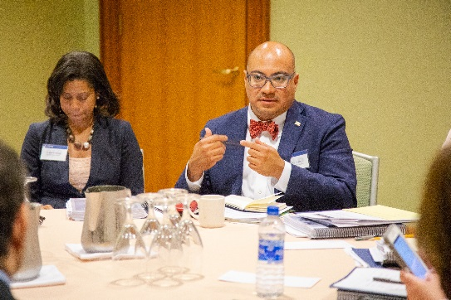
Strategic Planning & Technical Assistance
The goal of the HELP is to provide you with tools that can be immediately deployed within your organization. That’s why we ask every participant to enter the HELP program with the intention to either develop a year-long strategic plan that will be used as a blueprint for improving equity, or to advance a component of a specific project to address gaps in care. A project can be continuing an initiative already in progress or taking the first step on a new initiative. Examples include:
- Implementing a system to collect patients’ demographic data;
- Creating a “dashboard” to report quality data stratified by demographic data;
- Developing a training program to address unconscious bias;
- Evaluating a quality improvement intervention; or
- Partnering with the community to become an anchor institution.

Whether tackling a strategic plan or a project, as an applicant, you must propose the ways in which you would advance this work over the course of the year through participation in the HELP.

Throughout the year, the DSC will then work with you to achieve your project goals through technical assistance, including two interactive web-based calls that include the entire class, as well as three calls with a smaller group of HELP participants working on similar projects or in a similar context. Each organization will also be given the opportunity to have a TA call, where program faculty can meet one-on-one with a group to provide guidance and support.
“HELP offered me easy milestones and rest points in completion of my project. Because working on the project wasn't my only project, it gave me an opportunity to really sit with accomplishments and strategize how to elevate the work among our leaders.”
–HELP Alum

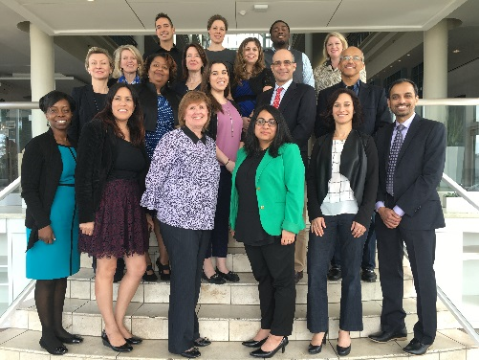
Closing Meeting and Final Project Presentation
The program ends with a one-day in-person closing meeting for your class in Boston, MA, where your team will present your work and lessons learned. Results will be shared with your peers, offering another opportunity to fine-tune your project and identify concrete steps forward, as well as interact and network with your peers, including other HELP alumni.

When the course is over, you will receive continuing education credits and a certificate of completion. Several projects will be chosen to receive an award for innovation, further elevating the visibility of this work within their organization.

Can my organization afford the HELP?
Health care organizations that adapt to meet the needs of their entire patient population – and ensure that they receive high-quality, value-based care – will ultimately lead in tomorrow’s health care marketplace.

At $11,500 per person, the HELP is a smart investment to ensure your organization is ready for the changes ahead. This fee, due on October 23, 2026, after your acceptance to the program, covers all program activities, including all training sessions and program materials. HELP participants are responsible for covering their travel and hotel costs for the in-person closing meeting in Boston.

Scholarships: If you require tuition assistance, please include a separate letter of request on your organization’s letterhead with your completed application. Important: Please include the amount of tuition assistance requested for your organization and explain your need for financial assistance. Partial scholarships may be available for individuals and teams from public hospitals, Medicaid health plans, and community health centers. Other organizations may be considered but are given lower priority.

Will I have time for the demands of the course?

We recognize that our participants are juggling many responsibilities and have, therefore, streamlined our program to be flexible and easily fit into your schedule.

The time commitment of the program is tailored to be minimal. Dates of the Zoom-based cohort call with the class will be released prior to the kick-off meeting so you can block the time in your calendar. All network calls with the entire class are recorded and archived so you can access them at your convenience if you can’t attend. In-person meetings in Boston require some time commitment due to traveling.

We also encourage HELP participants to choose an existing project or something they are currently tasked with so that it integrates well with their current responsibilities (rather than an extra add-on). And since you will be working on a live plan or project for your organization, you’ll be learning even as you accomplish goals you’re tasked with meeting. Lastly, generally, we recommend at least a team of 2 or more to distribute the time commitment among team members. Many folks have initial reservations about the time commitment, but our team works hard to tailor it to your needs, build flexibility into the program, and make it realistic given how busy everyone is.
“There were several takeaways from this program. One is that our journey is similar in many ways to others in this program. It has also been very gratifying to be able to look at where other organizations are struggling and realize we are farther ahead than we think! Pausing and acknowledging these efforts/successes has been really important. There is so much work that needs to be done, and even though we describe this as a journey and there are ups and downs, the importance of it for our members, community, and nation feels so critical. I also enjoyed working with different people from all across the healthcare spectrum about their projects and how their organizations operate. I also found the network of Alumni and MGH staff very helpful and informative when discussing how they achieve health equity from their specific scope. I now have a network of healthcare professionals with who we all share a connection, and I can consider them not as individuals but as friends.”
–HELP Alum

How Do I Apply?

Application Requirements
To maintain an effective learner-to-faculty ratio, and so that every participant can benefit fully, we limit the number of participants who participate in the HELP each year. We will review your application based on the following criteria:

- Level of organizational commitment to the applicant’s efforts as measured by:
- Letter of support signed by a member of your senior leadership or board, authorizing the time you will commit to the HELP and support for your tuition and travel expenses (templates will be provided); and
- Resources available (time and financial) within your organization to start or advance the project you take on through the HELP.
- Your commitment and ability to improve quality and achieve equity at your organization, as described in your short essay.
- Your role and capacity to lead your organization toward change.

Application Timeline
We encourage you to submit an Intent to Apply form prior to submitting a complete application. Both are available on our website at https://www.mghdisparitiessolutions.org/application-timeline.

The HELP 2026-2027 Virtual Kick-Off Meeting will likely take place November 5-6, 2026. Please review the application timeline and schedule below:

Friday, August 14, 2026 | Intent to Apply (recommended but not required)
Friday, September 4, 2026 | HELP Full Application due
Friday, September 11, 2026 | HELP applicants notified
Friday, September 25, 2026 | Acceptance deadline
Friday, October 23, 2026 | Tuition payment due
Tentative: Thursday, November 5 – Friday, November 6, 2026 | Virtual Kick-Off meeting
Date TBD – Oct 2027  (1 day) | In-person closing meeting in Boston

Policies
- Cancellations/Withdrawals: Please submit any withdrawal in writing. Cancellation notices received after September 25, 2026, but before October 23, 2026, will be charged a 25% processing fee. Cancellations made after October 23, 2026, will not receive a tuition refund.
- Continuing Education Credit: This program has been planned and implemented in accordance with the Essential Areas and policies of the Accreditation Council for Continuing Medical Education, through the joint sponsorship of the National Committee for Quality Assurance (NCQA) and Massachusetts General Hospital. This activity has been approved for AMA PRA Category 1 Credit™. NCQA is accredited as a provider of continuing nursing education by the American Nurses Credentialing Center’s Commission on Accreditation; continuing nursing education contact hours will be provided to participants.

To successfully complete this activity and receive CME or CNE credit, you must: sign the participant roster (at in-person meetings), remain for the entire program, and complete and submit a program evaluation. A certificate of completion specifying applicable credits will be available for each participant after the program.

Accessibility
The Disparities Solutions Center at Massachusetts General Hospital (MGH) considers all applicants and program participants without regard to race, color, national origin, age, religious creed, sex, gender identity, sexual orientation, or ability. We encourage participation by all individuals. If you need any of the auxiliary aids or services identified in the Americans with Disabilities Act, please describe your needs in writing and include them with this application.

Who leads the HELP?

Aswita Tan-McGrory, MBA, MSPH, is the Director at the Disparities Solutions Center. In her role as Director at the Disparities Solutions Center, Ms. Tan-McGrory leads the Center’s mission to equity in healthcare and works with healthcare leaders across the nation and internationally through the Health Equity Leadership Program.

Ms. Tan-McGrory is also a subject matter expert and public speaker and travels across the country to speak to organizations about health equity in quality of care. She participates in several in local and national committees, such as the Leapfrog Advisory Group on Equity, EOHHS Quality Measurement Taskforce, CMS Health Equity Quality Measurement Technical Expert Panel, and National Academy of Medicine Discussion Group on Collecting Data to Ensure Equity in Payment Policy.
​
Ms. Tan-McGrory’s interests are in providing equitable care to underserved populations, and she has over 20 years of professional experience in the areas of health equity, maternal/child health, elder homelessness, and HIV testing and counseling. She received her Master of Business Administration from Babson College and her Master of Science in Public Health, with a concentration in tropical medicine and parasitology, from Tulane University School of Public Health and Tropical Medicine. Ms. Tan-McGrory is a Returned Peace Corps Volunteer where she spent two years in rural Nigeria, West Africa, on water sanitation and Guinea Worm Eradication projects.
She received a YMCA Achievers award in 2017 for community service and professional achievement, and in 2016 was selected as a Pioneer as part of a groundbreaking initiative Children’s Wellbeing initiative by Ashoka Changemakers and the Robert Wood Johnson Foundation.

Lenny López, MD, MDiv, MPH, is Senior Faculty at the Disparities Solutions Center, Chief of Hospital Medicine, and Professor of Medicine at the University of California San Francisco. Dr. López is an internist trained at the Brigham and Women’s Hospital (BWH), who completed the Commonwealth Fund Fellowship in Minority Health Policy at the Harvard School of Public Health and a Hospital Medicine fellowship at BWH. Dr. López joined the Mongan Institute for Health Policy (MIHP) in 2008 after his research fellowship in General Internal Medicine at Massachusetts General Hospital (MGH). He was an Assistant Professor of Medicine at Harvard Medical School until 2015. With an ultimate goal of achieving health equity in cardiovascular disease and diabetes, his current research addresses issues relating to patient safety and language barriers, optimizing primary care clinical services for Latinos with cultural and linguistic barriers, and using health information technology to achieve health equity. The second line of research investigates the epidemiology of acculturation among Latinos in the US and its impact on the prevalence and development of cardiovascular disease and Type II diabetes. This research will help inform how to better design clinical interventions for improving chronic disease management among Latinos. Finally, Dr. López also teaches medical students and residents with lectures and preceptorships. Dr. López received his medical degree from the University of Pennsylvania in 2001 and completed his residency at Harvard Medical School, Brigham and Women’s Hospital, Boston, in 2004. At Harvard University, he received a Master of Divinity in 1999 and a Master of Public Health in 2005.

Alden M. Landry, MD, MPH, is an Associate Professor of Emergency Medicine physician at Beth Israel Deaconess Medical Center, Assistant Dean for the Office for Diversity Inclusion and Community Partnership, and Associate Director and Advisor for William B. Castle Society at Harvard Medical School. He also serves as Senior Faculty at the Disparities Solutions Center at Massachusetts General Hospital and is the founder and co-director of the non-profit organization Tour for Diversity. He strives to lead efforts for the Department of Emergency Medicine, the hospital, and the medical school to address health equity and improve the quality of care for the most disenfranchised.

In addition to his clinical interests, Dr. Landry is involved in research on Emergency Department utilization trends, gaps in care, and quality of care. He also co-instructs a course at Harvard T.H. Chan School of Public Health and teaches health equity to residents and physicians. Dr. Landry promotes careers in the health professions to under-represented minorities and mentors scores of pre-medical students, medical students, residents, fellows, and junior faculty. Dr. Landry also leads the Tour for Diversity in Medicine to increase the number of underrepresented minorities in medicine, dentistry, and other biomedical careers.

His peers and colleagues have recognized Dr. Landry as a health equity and social justice leader. He has received numerous awards for his public health work and efforts to promote healthcare workforce diversity. The Academy recently awarded him the Outstanding Academician Award for Diversity and Inclusion in Emergency Medicine of the Society of Academic Emergency Medicine and the Albert Frechette Award from the Massachusetts Public Health Association.

Dr. Landry received his Bachelor of Science degree from Prairie View A&M University in 2002 and his medical degree from the University of Alabama, Birmingham School of Medicine in 2006. He completed his residency in Emergency Medicine at the Beth Israel Deaconess Medical Center in 2009. In 2010, he earned a Master’s in Public Health degree from the Harvard T.H. Chan School of Public Health. He completed the Commonwealth Fund Fellowship in Minority Health Policy at Harvard University.

Esteban A. Barreto, PhD, MA, is an Instructor in Medicine at Harvard Medical School (HMS); Program Director of Research Evaluation at Massachusetts General Hospital (MGH); Core Faculty with the Mongan Institute Health Policy Research Center (HPRC), the Disparities Solutions Center (DSC), the Health Promotion and Resiliency Intervention Research Center (HPRIR), and the Office of Clinical Research within Mass General Brigham (MGB); and co-investigator with the Center for Suicide Research and Prevention (CSRP) at MGH and Harvard University and with Supporting Practices in Respecting Elders (SPIRE) at MGB and Brandeis University.

For over a decade, Esteban has led research and quality improvement efforts in health equity, with a focus on access for underserved populations, including patients with limited English proficiency. Esteban holds a Master’s degree and a PhD in Industrial/Organizational Psychology from the University of Puerto Rico, and a Bachelor of Arts from the University of Massachusetts. Esteban is a certified medical interpreter and a qualified bilingual staff member.

Christopher J. Kirwan, PhD, is the Director of Enterprise Language Services at Mass General Brigham, the Director of Interpreter Services at Massachusetts General Hospital, and a Co-chair of the Education and Action Committee of the Inclusion Campaign at MGH. He holds a doctorate in ethics from the Accademia Alfonisana in Rome, Italy, where he lived and attended school for eight years. He taught in the field of social ethics for many years before coming to MGH in 2006.

Chris is the President of the Board of Directors of FOCIS (Forum on the Coordinators of Interpreter Services), which gathers coordinators of Interpreter Service Departments from all over the United States. Chris has co-authored four articles in peer-reviewed journals on the importance of using interpreter services for vulnerable populations. He is also involved in several projects across MGB focused on health equity for patients and their families with language access needs. Chris was a long-standing member of the Collaborative Governance Ethics in Clinical Practice Committee and the Coach of the Diversity and Inclusion Committee of PCS’s Collaborative Governance. English is Chris’ first language and he is proficient in Spanish and Italian and has studied four others; he also has a deep passion for and commitment to efforts focused on diversity, inclusion, equity and belonging.
Andrea Tull, PhD, expertise is in analytics, data visualization, policy and program evaluation in the social service and healthcare industries, with emphasis on elders, people with disabilities and underserved populations. In her role as Vice President of Analytics and Data Visualization at Sellers Dorsey, Andrea leads a broad portfolio of analytic projects in the areas of value-based care, access, health equity, and quality of care. Prior to joining Sellers Dorsey, Andrea led analytics teams at Massachusetts General Hospital and Mass General Brigham, where she has partnered with the MGH Disparities Solutions Center. For the past 10 years, she has helped the DSC team measure equity and design improvement strategies. She is passionate about seeking out gaps in clinical care and supporting health equity improvement through robust program evaluation frameworks.

Andrea has a PhD in Gerontology from the University of Massachusetts and continues to volunteer in the elder services field at several elder senior living properties in the Boston area.

“The HELP is a great network with members who are knowledgeable and in the leading edge of this line of work. It enables me to show myself as a better qualified professional. I am able to say that I was a participant in a program with an excellent reputation whose members are national leaders, experts, and practitioners.”
– HELP Alum

Where can I find more information?

For more information on the HELP and the Disparities Solutions Center at MGH, please visit:
https://www.mghdisparitiessolutions.org/health-equity-leadership-program

For additional information, contact:
Mackenzie Clift
Project Manager, The Disparities Solutions Center
Massachusetts General Hospital
100 Cambridge Street, Suite 1600
Boston, MA 02114
Email: mclift@mgh.harvard.edu
Phone: (617) 724-4613

